**VISVESVARAYA TECHNOLOGICAL UNIVERSITY**

**“Jnana Sangama”, Machhe, Belagavi, Karnataka-590018**

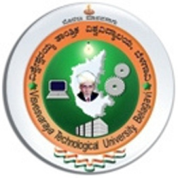

A Mini-Project Report on

**“Life Cycle of Frog”**

***Submitted in partial fulfillment for the award of degree of Bachelor of Engineering in Computer Science and Engineering during the year 2015-16***

**Submitted by**

**Anusha C A (4GW13CS011)**

**Nikitha N (4GW13CS060)**

**Under the Guidance of**

**VISHWESH J USHA RANI J**

**Assistant Professor Assistant Professor**



**DEPARTMENT OF COMPUTER SCIENCE AND ENGINEERING**

**GSSS INSTITUTE OF ENGINEERING & TECHNOLOGY FOR WOMEN**

**(**Affiliated to VTU, Belagavi, Approved by AICTE, New Delhi & Govt. of Karnataka)

K.R.S Road, Metagalli, Mysuru-570016